Government Engineering College, Thrissur
CS334 – Network Programming Lab
Documentation -
Exp 7 – Raw sockets and Sniffing

Date of Submission
30 May 2021

Submitted By
Kowsik Nandagopan D
Roll No 31
TCR18CS031
GECT CSE S6

Experiment 7
a)Display the header information of UDP and TCP packets during client-server communication using raw sockets.
b) Develop a packet capturing and filtering application using raw sockets.

Executing program

Part a
- Code is provided in the raw_tcp.c and raw_udp.c. (Tested and verified on Ubuntu 20.04)
gcc raw_tcp.c -o raw_tcp && sudo ./raw_tcp
gcc raw_udp.c -o raw_udp && sudo ./raw_udp
- Note: Raw sockets must be executed in sudo mode.
- Since we cannot multitask same time, we are looping the send command infinte time. To stop the program, use CTRL + C

TCP Raw Sockets Algorithm
- TCP raw sockets are created
- Create new datagram and allocate it in memory
- Assign the parameters of headers that include IP header, TCP header, and data
- Checksum can be included to validate the integrity of the information
- Forward the data from the server to the client
- Exit (We can also loop through the action if required)

P. T. O
UDP Raw Sockets Algorithm
- UDP raw sockets are created
- Create new buffer and allocate it in memory
- Assign the parameters of headers that include IP header, UDP header, and data
- Checksum can be included to validate the integrity of the information
- Forward the data from the server to the client
- Exit (We can also loop through the action if required)

Part b
- Code is provided in the sniffer.c. (Tested and verified on Ubuntu 20.04)
gcc sniffer.c -o sniffer && sudo ./sniffer
- Note: Raw sockets must be executed in sudo mode.
Algorithm
- Create buffers and allocate dynamically
- Create web sockets
- Process the packets based on the packet received.
- Iphrd = size of buffer + ethhdr
- If the TCP is received print the TCP header information, apply the same action to UDP

P. T. O

Output / Screenshots

Part a
Raw TCP
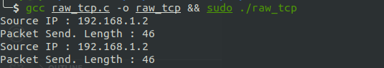

Raw UDP
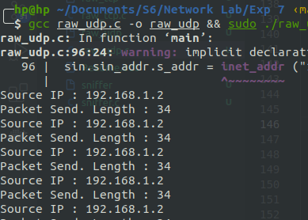

P. T. O

Part b
TCP Header captured by sniffer

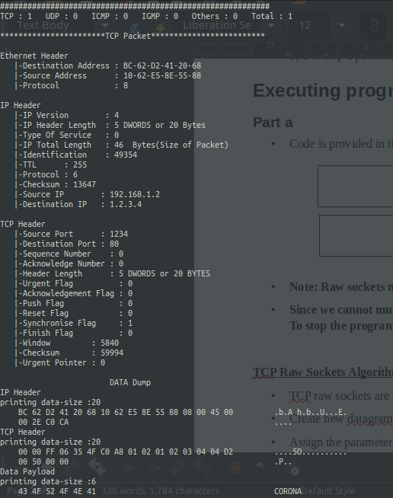

P. T. O
UDP Header captured by sniffer

